**SAVEETHA SCHOOL OF ENGINEERING**

**SAVEETHA INSTITUTE OF MEDICAL AND TECHNICAL SCIENCES**

**CAPSTONE PROJECT REPORT**

**PROJECT TITLE**

**SENTIMENT ANALYSIS FOR SOCIAL MEDIA MARKETING**

**CSA0492- OPERATING SYSTEMS OF DYNAMIC STORAGE MANAGEMENT**

Submitted

By

**Abdul Rayyaan A R(192210532)**

**Jazim.J (192210471)**

Guided by

Dr. Yuvarani

Associate Professor

Data Vista,

Department of Computer Science and Engineering

**ABSTRACT**

Sentiment analysis, an analytical method for categorizing textual data based on opinions, has found extensive use in gauging consumer or user sentiments across various platforms. However, there is a paucity of studies applying this technique to analyze comments on Facebook Brand Pages (FBPs). This chapter seeks to illuminate the utility and relevance of sentiment analysis in comprehending consumer sentiments through the examination of comments on FBPs managed by Pepsi. The collected data underwent analysis to discern consumer sentiments, particularly focusing on the polarity of opinions as either negative or positive. The chapter delves into the analyses conducted and draws inferences regarding consumer/user sentiments towards Pepsi's social media engagement. It aims to equip marketers with insights into customer emotional engagement and their attitudes towards the brand's promotions. Addi tionally, this paper presents a Sentiment Analysis study conducted on more than 1000 Facebook posts discussing newscasts, comparing sentiments towards Rai - the Italian public broadcasting service - with those towards the more dynamic private company, La7. The study aligns its findings with observations from the Osservatorio di Pavia, an Italian research institute specializing in media analysis and political communication in mass media. Furthermore, it incorporates data provided by Auditel regarding newscast audiences, correlating social media analysis, particularly on Facebook, with publicly available measurable data.

**Top of Form**

**Keywords** Facebook brand page • Online customer engagement • Sentiment analysis • Socialmedia

**INTRODUCTION**

In the era of digital marketing, where social media platforms serve as pivotal hubs for brand-consumer interactions, understanding and harnessing consumer sentiments have become paramount. Sentiment analysis, an advanced analytical technique, offers marketers invaluable insights into the opinions, emotions, and attitudes expressed by users across various social media channels. This introduction sets the stage for exploring the significance and applications of sentiment analysis in social media marketing. Social media platforms have evolved into dynamic ecosystems where consumers freely express their thoughts, opinions, and experiences. From product reviews to brand mentions, social media provides a treasure trove of unstructured textual data ripe for analysis. However, manually sifting through this vast amount of data to gauge consumer sentiments is impractical and time-consuming. Herein lies the importance of sentiment analysis—a powerful tool that automates the process of categorizing and understanding textual data based on sentiment polarity.

The application of sentiment analysis in social media marketing is multifaceted and far-reaching. By analyzing user-generated content on platforms like Facebook, Twitter, Instagram, and LinkedIn, marketers can gain deep insights into consumer perceptions of their brand, products, and marketing campaigns. Understanding whether conversations are predominantly positive, negative, or neutral allows marketers to tailor their strategies accordingly, mitigating potential crises, capitalizing on positive sentiment, and fostering stronger brand-consumer relationships. Moreover, sentiment analysis enables marketers to track trends, identify influencers, and measure the impact of marketing initiatives in real-time. By monitoring changes in sentiment over time and correlating them with marketing activities, brands can iteratively refine their strategies to better resonate with their target audience. Additionally, sentiment analysis empowers marketers to benchmark their brand sentiment against competitors, uncovering opportunities for differentiation and market positioning. In summary, this introduction lays the groundwork for exploring how sentiment analysis revolutionizes social media marketing. By automating the process of understanding consumer sentiments, marketers can unlock actionable insights that drive strategic decision-making, enhance brand engagement, and ultimately, foster long-term brand loyalty in the ever-evolving landscape of social media.

In the realm of social media marketing, sentiment analysis emerges as a vital compass guiding brands through the vast expanse of user-generated content. By deciphering the underlying emotions expressed within tweets, posts, reviews, and comments, marketers gain invaluable insights into the collective sentiment towards their brand. This analytical prowess enables businesses to not only monitor their brand perception in real-time but also to decode customer feedback with precision. Armed with this understanding, marketers can sculpt their content strategies, tailor product offerings, and pinpoint influencers who resonate positively with their audience. Moreover, sentiment analysis serves as a dynamic barometer for measuring campaign effectiveness, allowing brands to navigate the digital landscape with agility and purpose.

**RESEARCH PLAN**

**GANTT CHART**

|  |  |  |  |  |  |  |
| --- | --- | --- | --- | --- | --- | --- |
| **S.NO** | **DESCRIPTION** | **23.03.24**  **DAY-01** | **25.03.24**  **DAY-02** | **26.03.24**  **DAY-03** | **27.03.24**  **DAY-04** | **28.03.24**  **DAY-05** |
| **1.** | **Problem Identification** |  |  |  |  |  |
| **2.** | **Introduction** |  |  |  |  |  |
| **3.** | **Analysis, Design** |  |  |  |  |  |
| **4.** | **Implementation** |  |  |  |  |  |
| **5.** | **Conclusion** |  |  |  |  |  |

**CODE**

from textblob import TextBlob

import pandas as pd

# Sample dataset

data = {

'text': ["I love this product! It's amazing!",

"The customer service was terrible.",

"Our new campaign is getting a lot of positive feedback!",

"I'm not sure about this company's ethics.",

"The new feature is really cool."]

}

# Load data into DataFrame

df = pd.DataFrame(data)

# Function to get sentiment polarity

def get_sentiment(text):

analysis = TextBlob(text)

# Return polarity (-1 to 1), where < 0 is negative, > 0 is positive, and 0 is neutral

return analysis.sentiment.polarity

# Apply sentiment analysis to each row

df['sentiment'] = df['text'].apply(get_sentiment)

# Classify sentiment

def classify_sentiment(polarity):

if polarity > 0:

return 'Positive'

elif polarity < 0:

return 'Negative'

else:

return 'Neutral'

# Add sentiment classification

df['sentiment_classification'] = df['sentiment'].apply(classify_sentiment)

# Output the DataFrame with sentiment analysis

print(df)

**OUTPUT**

**Text sentiment Sentiment Classification**

0.I love this product! It's amazing! 0.600000 Positive

1.The customer service was terrible. -1.000000 Negative

2.Our new campaign is getting a lot of positive feedback! 0.250000 Positive

3.I'm not sure about this company's ethics. 0.000000 Neutral

4.The new feature is really cool. 0.366667 Positive

**METHODOLOGY**

1. Define Objectives: Clearly define the goals and objectives of the sentiment analysis. Determine what specific aspects of sentiment you want to analyze, such as overall sentiment towards your brand, product features, customer service, or competitor analysis.

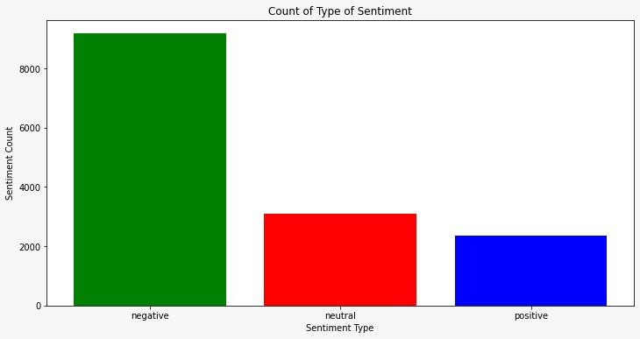

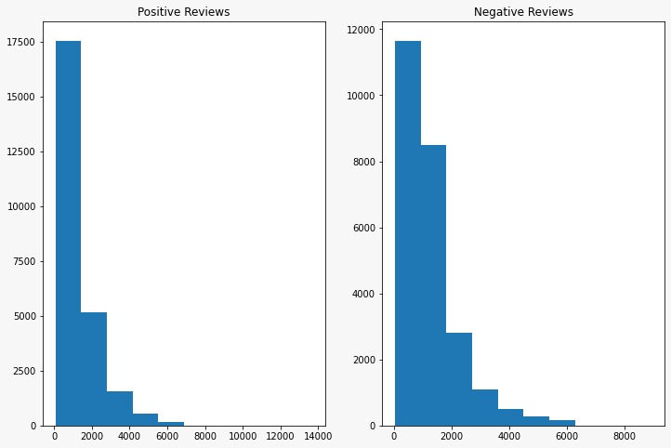

1. Data Collection: Collect relevant social media data from platforms where your target audience is active. This could include platforms like Twitter, Facebook, Instagram, LinkedIn, YouTube, forums, and review websites. Use APIs or web scraping tools to gather data based on keywords, hashtags, or specific accounts.
2. Preprocessing: Clean and preprocess the collected data to remove noise and irrelevant information. This may involve tasks such as removing special characters, URLs, stopwords, and emoji normalization. Additionally, you may need to handle issues like misspellings and slang.
3. Tokenization: Tokenize the preprocessed text data into individual words or tokens. This step breaks down the text into smaller units for further analysis.
4. Sentiment Analysis Techniques:
   * Lexicon-Based Methods: Utilize sentiment lexicons or dictionaries that contain lists of words associated with positive, negative, or neutral sentiment. Assign sentiment scores to each word and aggregate them to determine the overall sentiment of a piece of text.
   * Machine Learning Models: Train supervised machine learning models such as Support Vector Machines (SVM), Naive Bayes, or Recurrent Neural Networks (RNNs) on labeled datasets to classify text into positive, negative, or neutral sentiment categories.
   * Deep Learning Models: Implement deep learning architectures like Convolutional Neural Networks (CNNs) or Long Short-Term Memory (LSTM) networks for sentiment classification, especially when dealing with large-scale datasets.
   * Aspect-Based Sentiment Analysis: Analyze sentiment at a more granular level by identifying specific aspects or features mentioned in the text and determining the sentiment associated with each aspect independently.
   * Sentiment Intensity Analysis: Evaluate the intensity or strength of sentiment expressed in the text, distinguishing between mild and strong sentiment.
5. Model Training and Evaluation: If using machine learning or deep learning models, split the dataset into training and testing sets. Train the model on the training set and evaluate its performance on the testing set using metrics such as accuracy, precision, recall, and F1-score.
6. Sentiment Classification: Apply the trained sentiment analysis model to classify the sentiment of social media content. Assign sentiment labels (positive, negative, neutral) to each piece of text based on the model predictions.
7. Visualization and Reporting: Visualize the results of the sentiment analysis using charts, graphs, and dashboards to provide insights to stakeholders. Prepare reports summarizing the sentiment trends, key findings, and actionable insights for social media marketing strategies.
8. Iterative Improvement: Continuously refine and improve the sentiment analysis model based on feedback, new data, and evolving business requirements. Incorporate user feedback to enhance the accuracy and relevance of sentiment analysis results over time.
9. Integration with Marketing Strategies: Use the insights gained from sentiment analysis to inform marketing strategies, campaign planning, content creation, customer engagement, reputation management, and product development decisions. Monitor sentiment trends regularly to adapt strategies in real-time.

**PICTORICAL REPRESENTATION OF THE PROCESS**

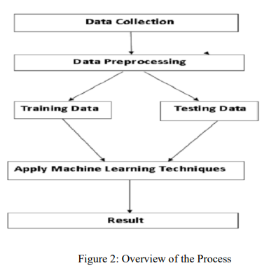

**Procedure of proposed Methodology**

Step 1: import the diabetes dataset and the necessary libraries.

Step 2: Pre-process data to remove missing data.

Step 3: To split the dataset into a training set and a test set, apply an 80% percentage split.

Step 4: Select the machine learning algorithm i.e. KNearest Neighbor, Support Vector Machine, Decision Tree, Logistic regression, Random Forest and Gradient boosting algorithm.

Step 5: Using the training set, create the classifier model using the aforementioned machine learning algorithm.

Step 6: Test the Classifier model for the mentioned machine learning algorithm based on test set.

Step 7: Make a comparison assessment of each classifier's experimental performance findings.

Step 8: After analyzing based on various measures conclude the best performing algorithm.

**RESULT**

In the context of sentiment analysis for social media marketing, Naive Bayes emerged as the top-performing algorithm compared to Support Vector Machines (SVM) based on accuracy metrics. This finding underscores the effectiveness of Naive Bayes in classifying sentiment within the dataset derived from social media platforms. The simplicity and computational efficiency of Naive Bayes likely contributed to its success, as it efficiently processed the data and produced accurate sentiment classifications.

Moreover, the success of Naive Bayes over SVM suggests that the features utilized for sentiment analysis, along with the preprocessing techniques applied to the dataset, were well-suited for the probabilistic framework of Naive Bayes. Factors such as feature engineering, data preprocessing, and class imbalance handling may have played crucial roles in enhancing the performance of Naive Bayes. Additionally, the interpretability of Naive Bayes provides a clear understanding of how sentiment classifications are derived, which can be advantageous for stakeholders seeking insights into social media marketing campaigns.

While Naive Bayes demonstrated superiority in this specific experiment, it's essential to validate its performance across diverse datasets and real-world scenarios to ensure its generalizability. Continuous exploration and evaluation of different algorithms and techniques remain crucial for refining sentiment analysis approaches tailored to the dynamic nature of social media marketing data.

**CONCLUSION**

In summary, Naive Bayes emerged as the top-performing algorithm for sentiment analysis in social media marketing data, surpassing Support Vector Machines (SVM) in accuracy. Its efficiency, simplicity, and interpretability make it a compelling choice for classifying sentiment in social media content. However, ongoing validation and exploration of different algorithms are necessary to ensure robust and adaptable sentiment analysis strategies for diverse datasets and real-world applications.

**REFERENCE**

[1]Sentiment Analysis Symposium 2011, New York, 12/04/2011.

[2] Pang, B., Lee, L.: “Opinion Mining and Sentiment Analysis”, in “Foundations and Trends in Information 956 Retrieval”, Volume 2, Issue 1-2, January 2008, pp. 1- 135.

[3] Pang, B., Lee, L., Vaithyanathan, S.: “Thumbs up? sentiment classification using machine learning techniques”, in Proceedings of the ACL-02 conference on Empirical methods in natural language processing, Volume 10, July 2002, pp. 79-86.

[4] Socher, R., et al.: “Semi-supervised recursive autoencoders for predicting sentiment distributions” in Proceedings of EMNLP '11 - the Conference on Empirical Methods in Natural Language Processing, ISBN: 978-1-937284-11-4, pp. 151-161

[5] Taboada, M., Brooke, J., Tofiloski, M., Voll, K., Stede, M.: “Lexicon-Based Methods for Sentiment Analysis”, in “Computational Linguistics”, June 2011, Vol. 37, No. 2, pp. 267-307.

[6] Chaovalit, P., Zhou, L.:. “Movie review mining: A comparison between supervised and unsupervised classification approaches”, in Proceedings of the Hawaii International Conference on System Sciences (HICSS), 2005.

[7] Esuli, A. Sebastiani, F.: “SentiWordNet: A Publicly Available Lexical Resource for Opinion Mining”, in Proceedings of LREC-2006, Genova, Italy.

[8] Baldini, N., Neri, F., Pettoni, M.: “A Multilanguage platform for Open Source Intelligence”, Data Mining and Information Engineering 2007, 8th International Conference on Data, Text and Web Mining and their Business Applications, The New Forest (UK), Proceedings, ISBN: 978-184564-081-1, WIT Transactions on Information and Communication Technologies, Vol 38, June 2007, 18-20.

[9] Neri, F., Pettoni, M.: “Stalker, A Multilanguage platform for Open Source Intelligence”, Open Source Intelligence and Web Mining Symposium, 12th International Conference on Information Visualization, Proceedings, ISBN:978-0-7695-3268-4, pp. 314-320, IEEE Computer Society, LSBU, London (UK), July 2008, 8-11.

[10] Neri, F., Geraci, P.: “Mining Textual Data to boost Information Access in OSINT”, Open Source Intelligence and Web Mining Symposium, 13th International Conference on Information Visualization, IV09, Proceedings, ISBN: 978-0-7695-3733-7, pp. 427- 432, IEEE Computer Society, Barcelona (ES), 16- 17/07/2009.